**Assignment 3 (Benchmark)**

Name: Aashay Pawar

NUID: 002134382

***Part 1 - You are to implement three (3) methods (repeat, getClock, and toMillisecs) of a class called Timer.***

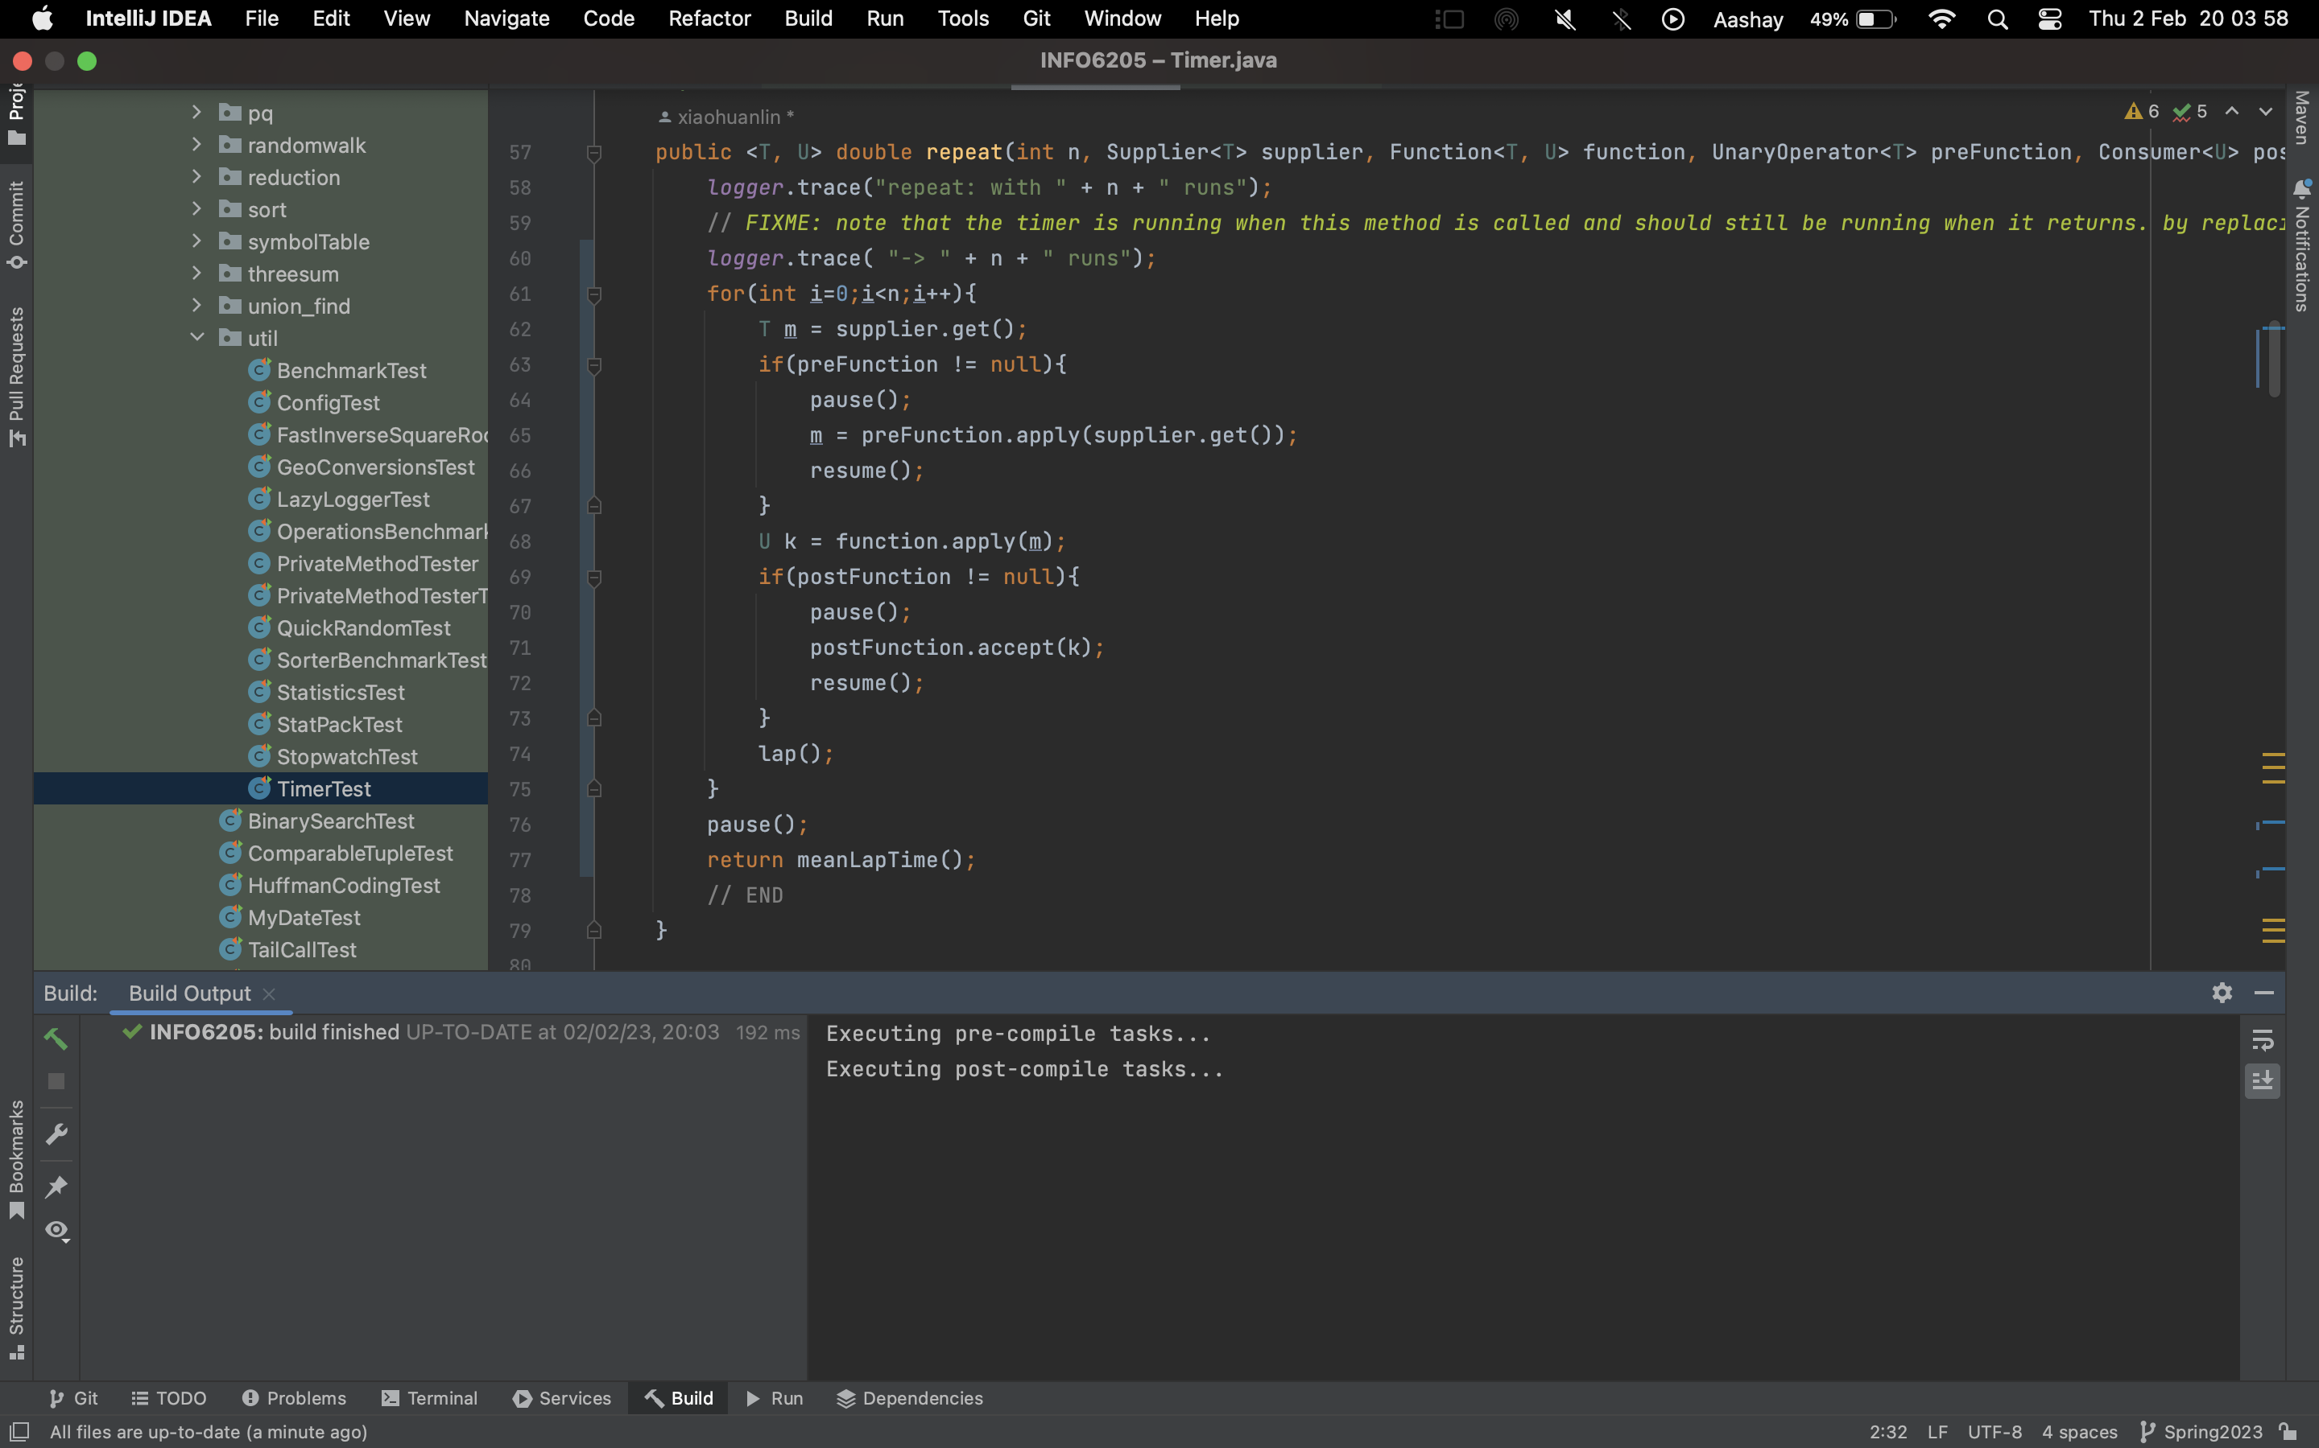

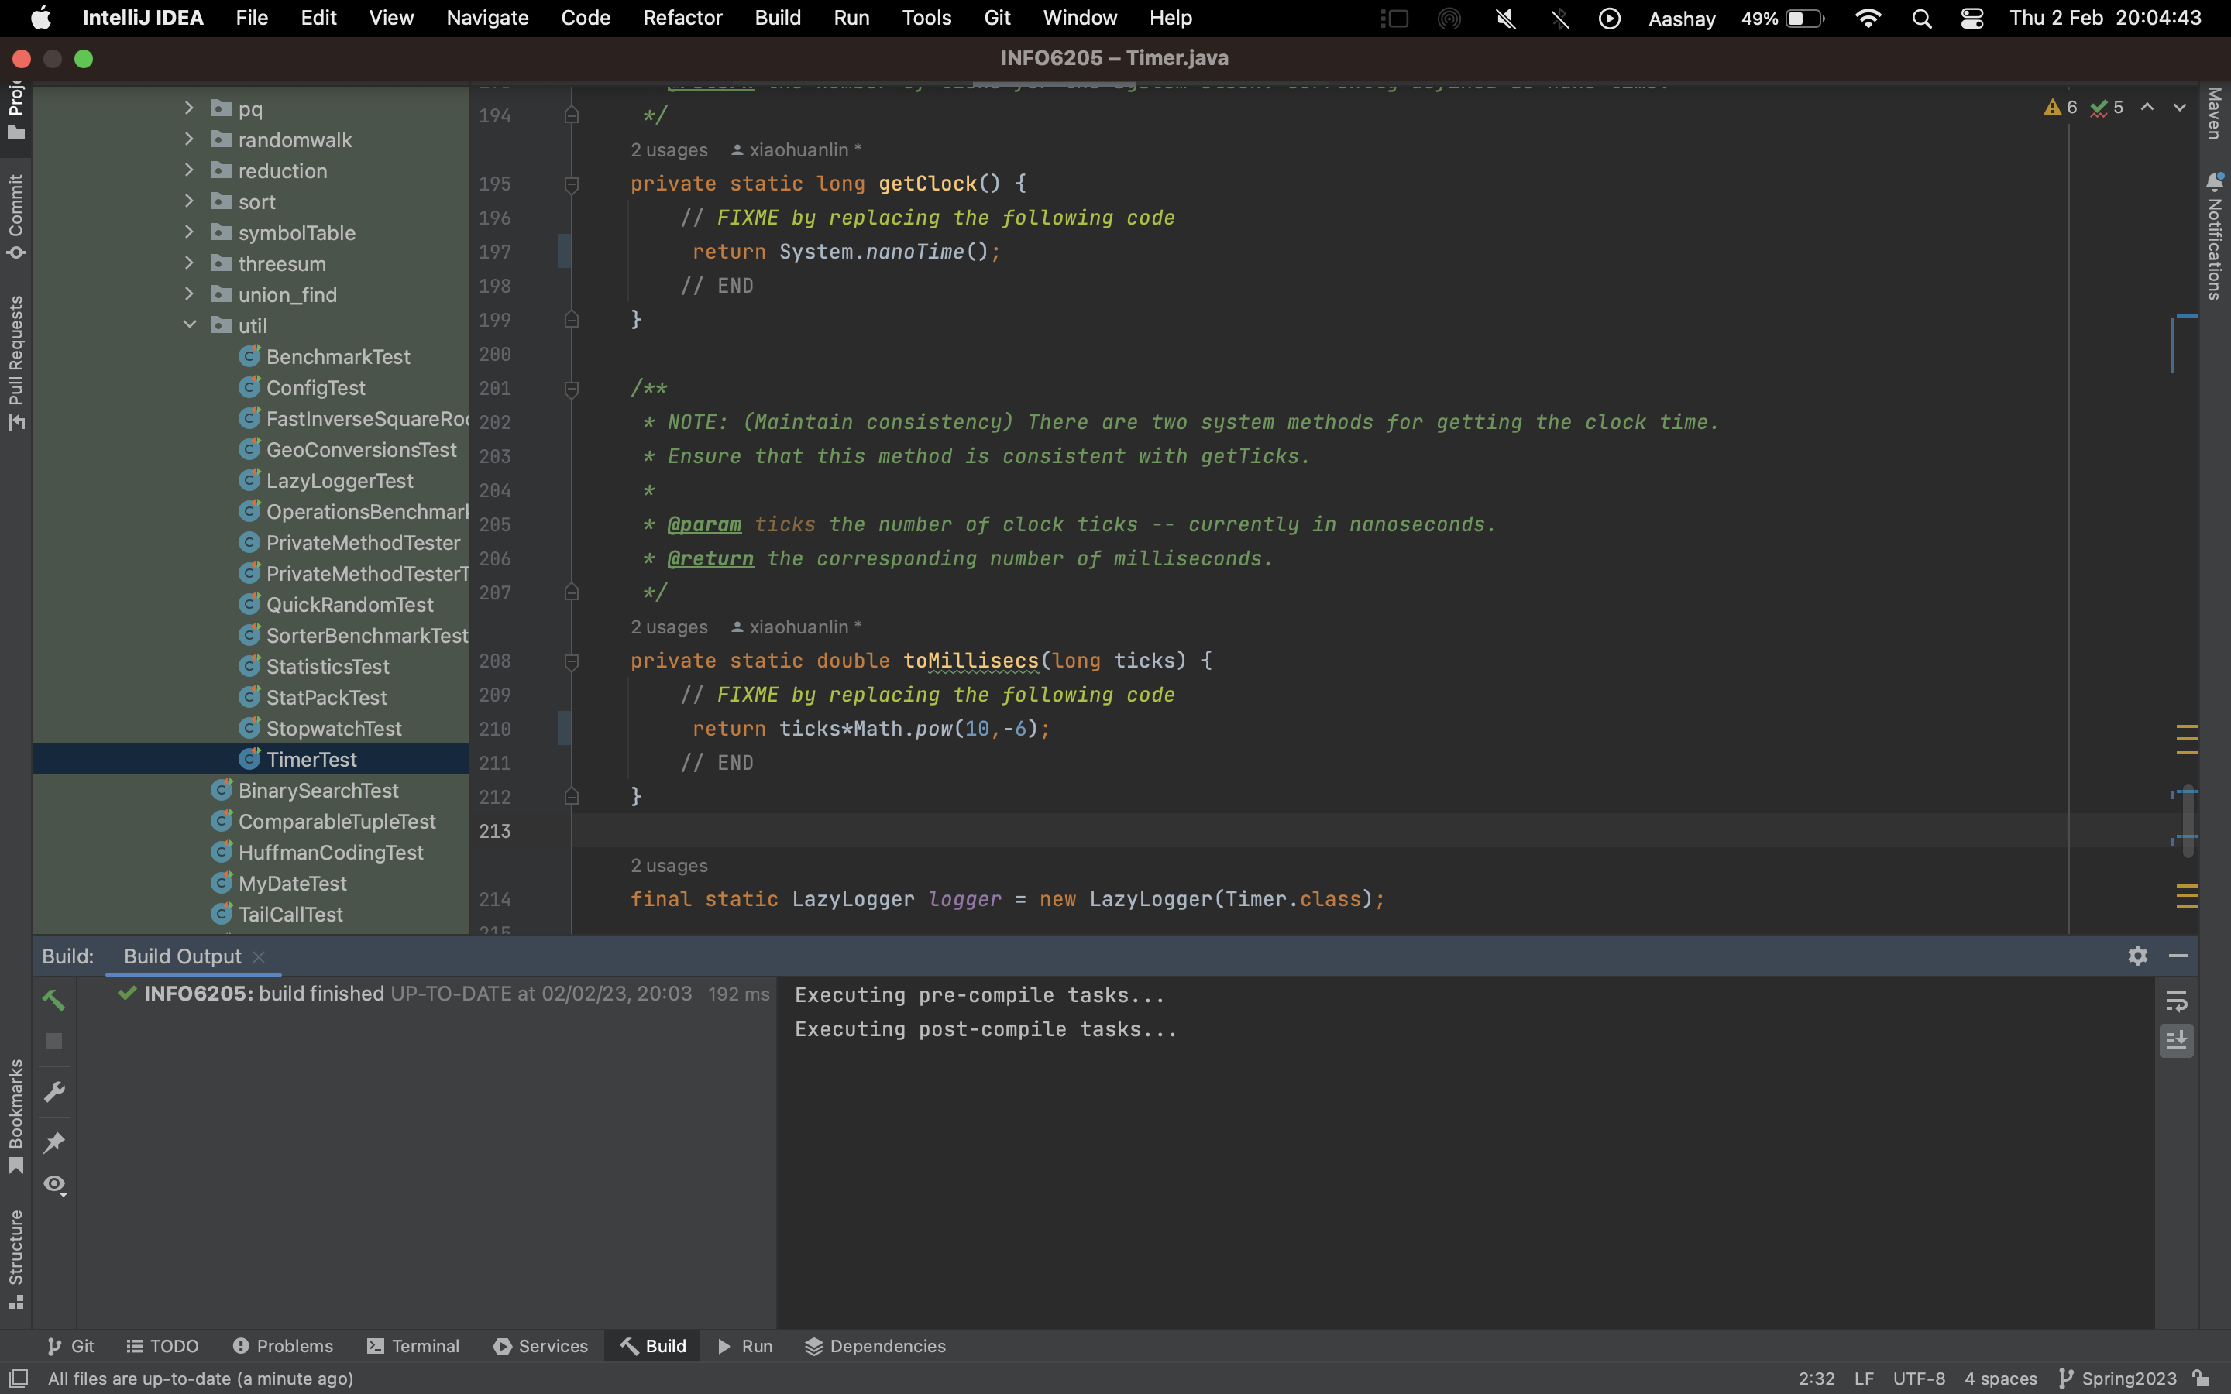

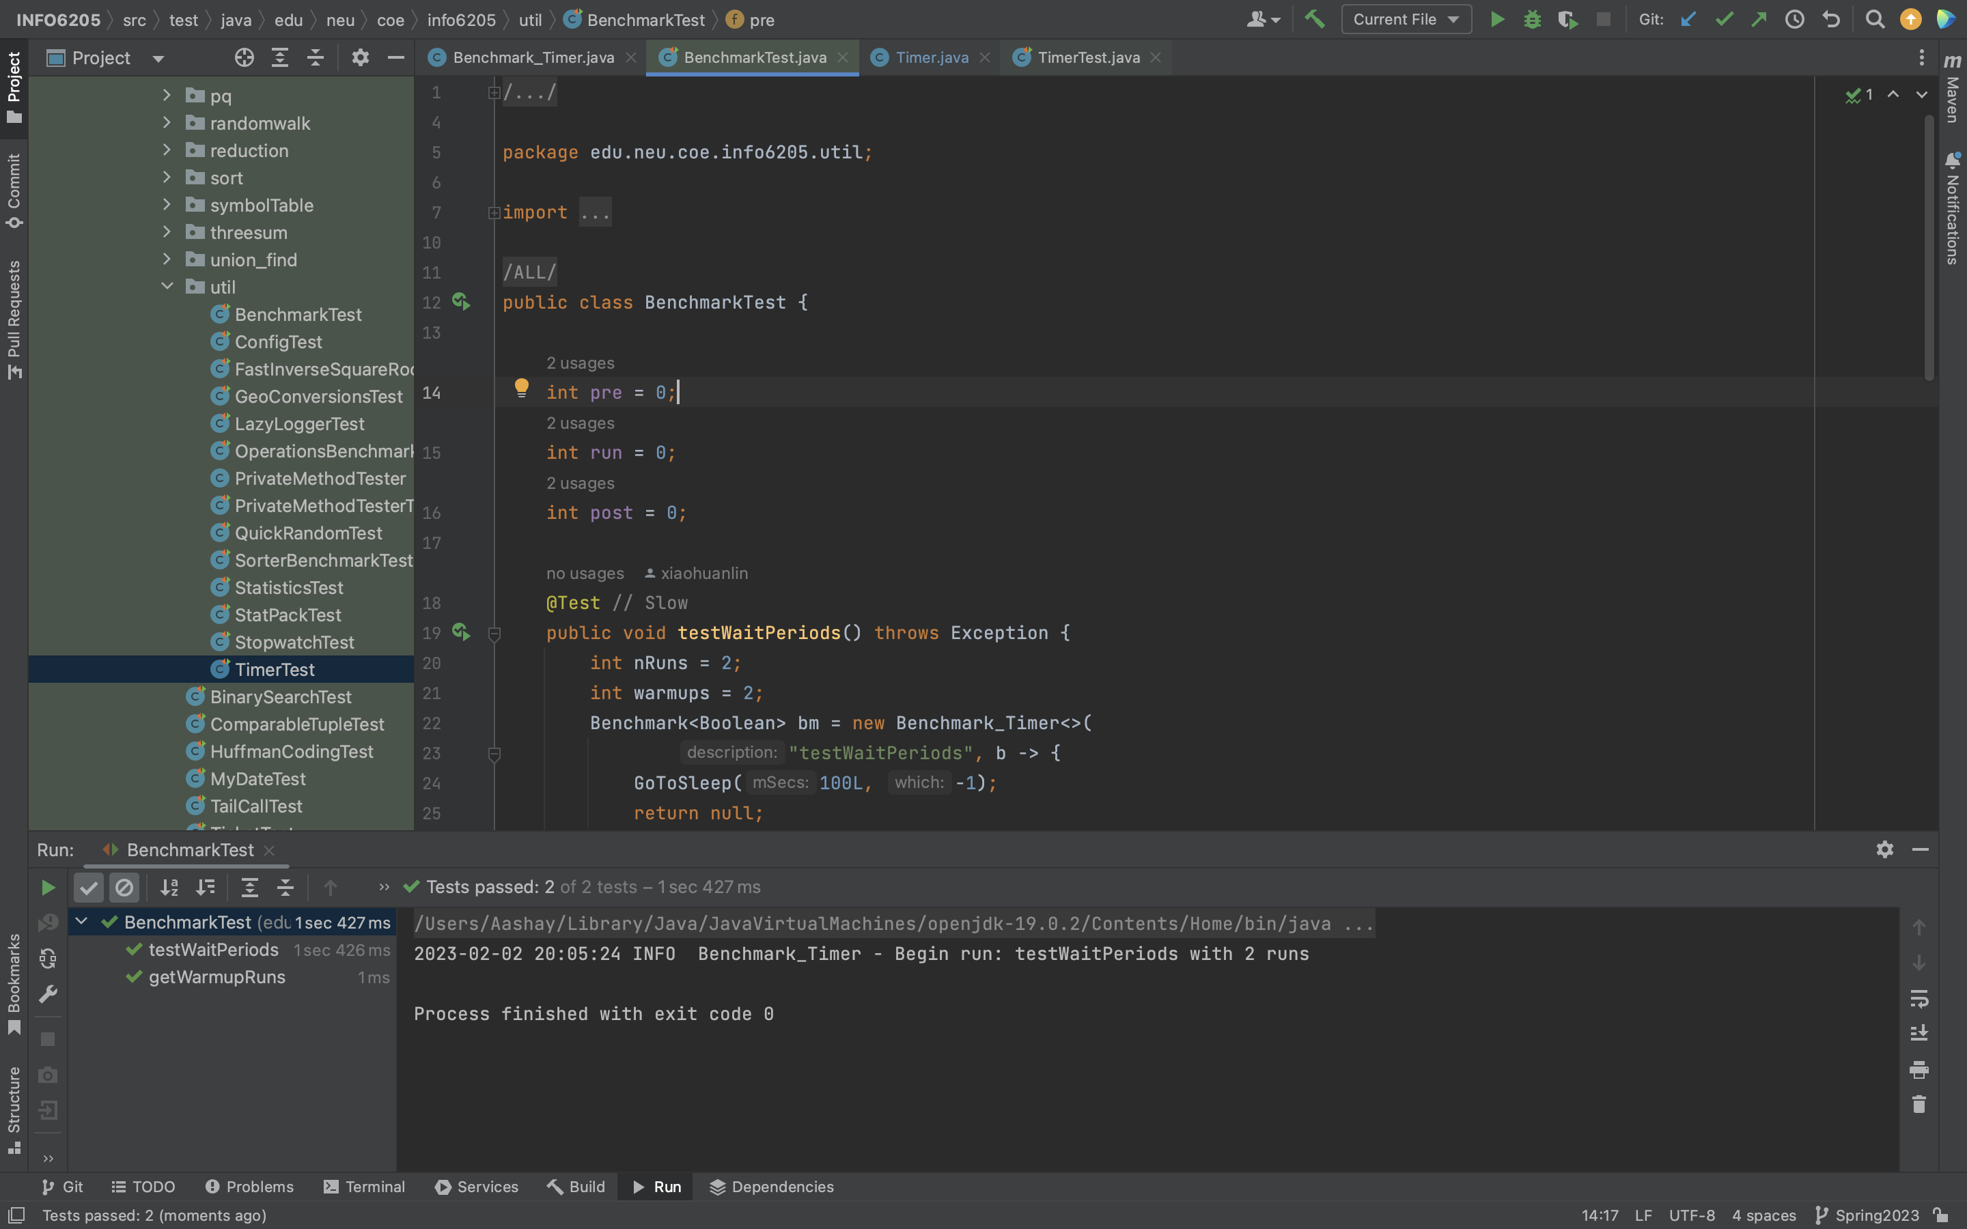

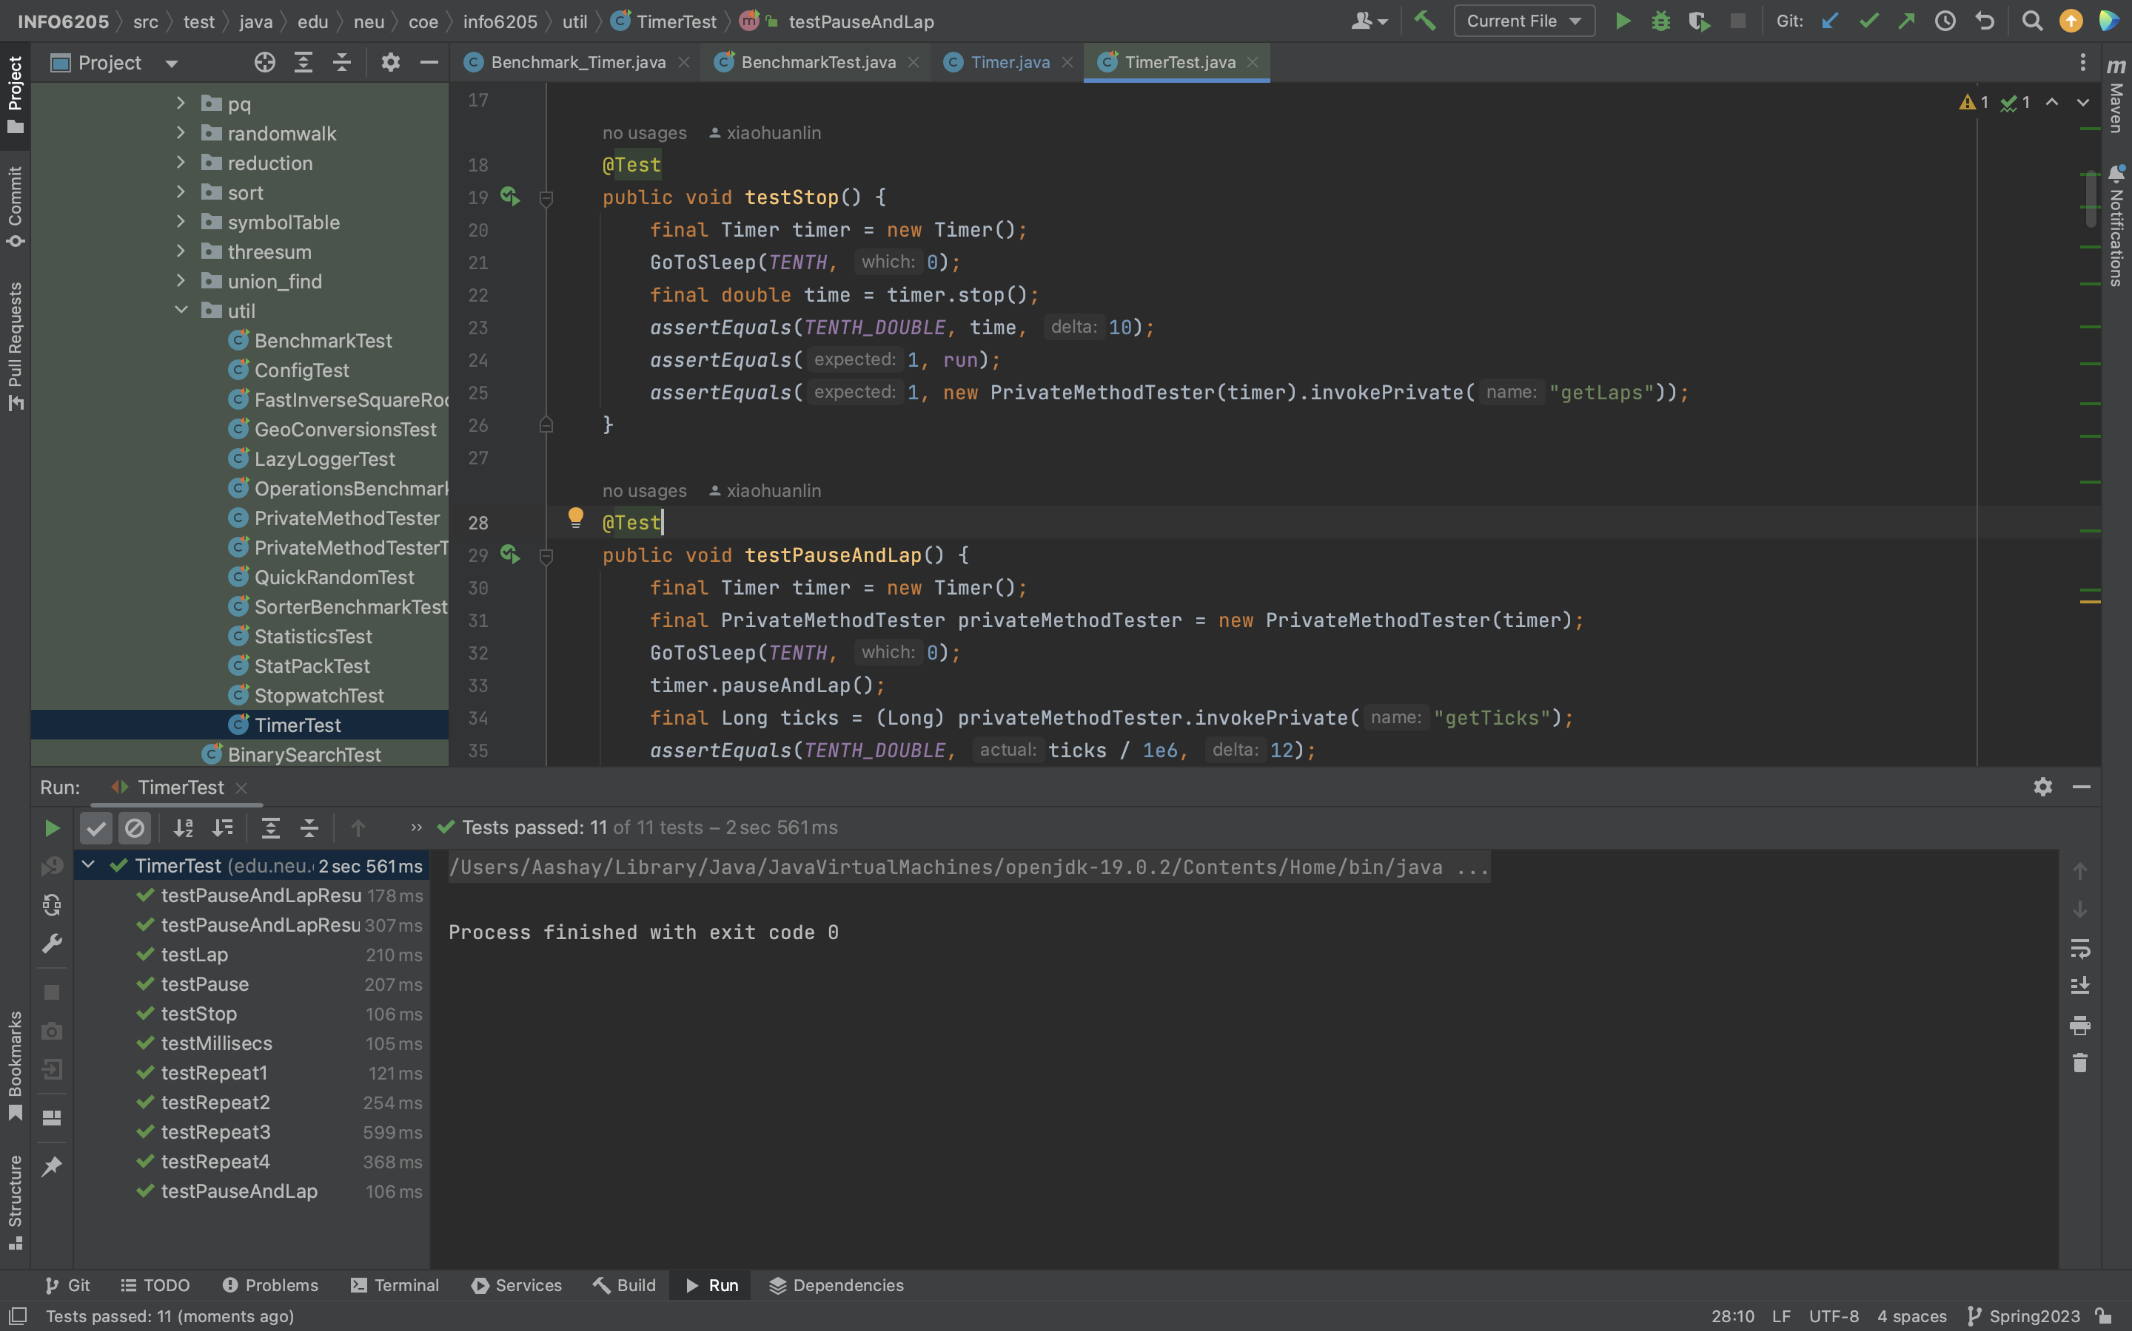

***Part 2 - Implement InsertionSort (in the InsertionSort class) by simply looking up the insertion code used by Arrays.sort.***

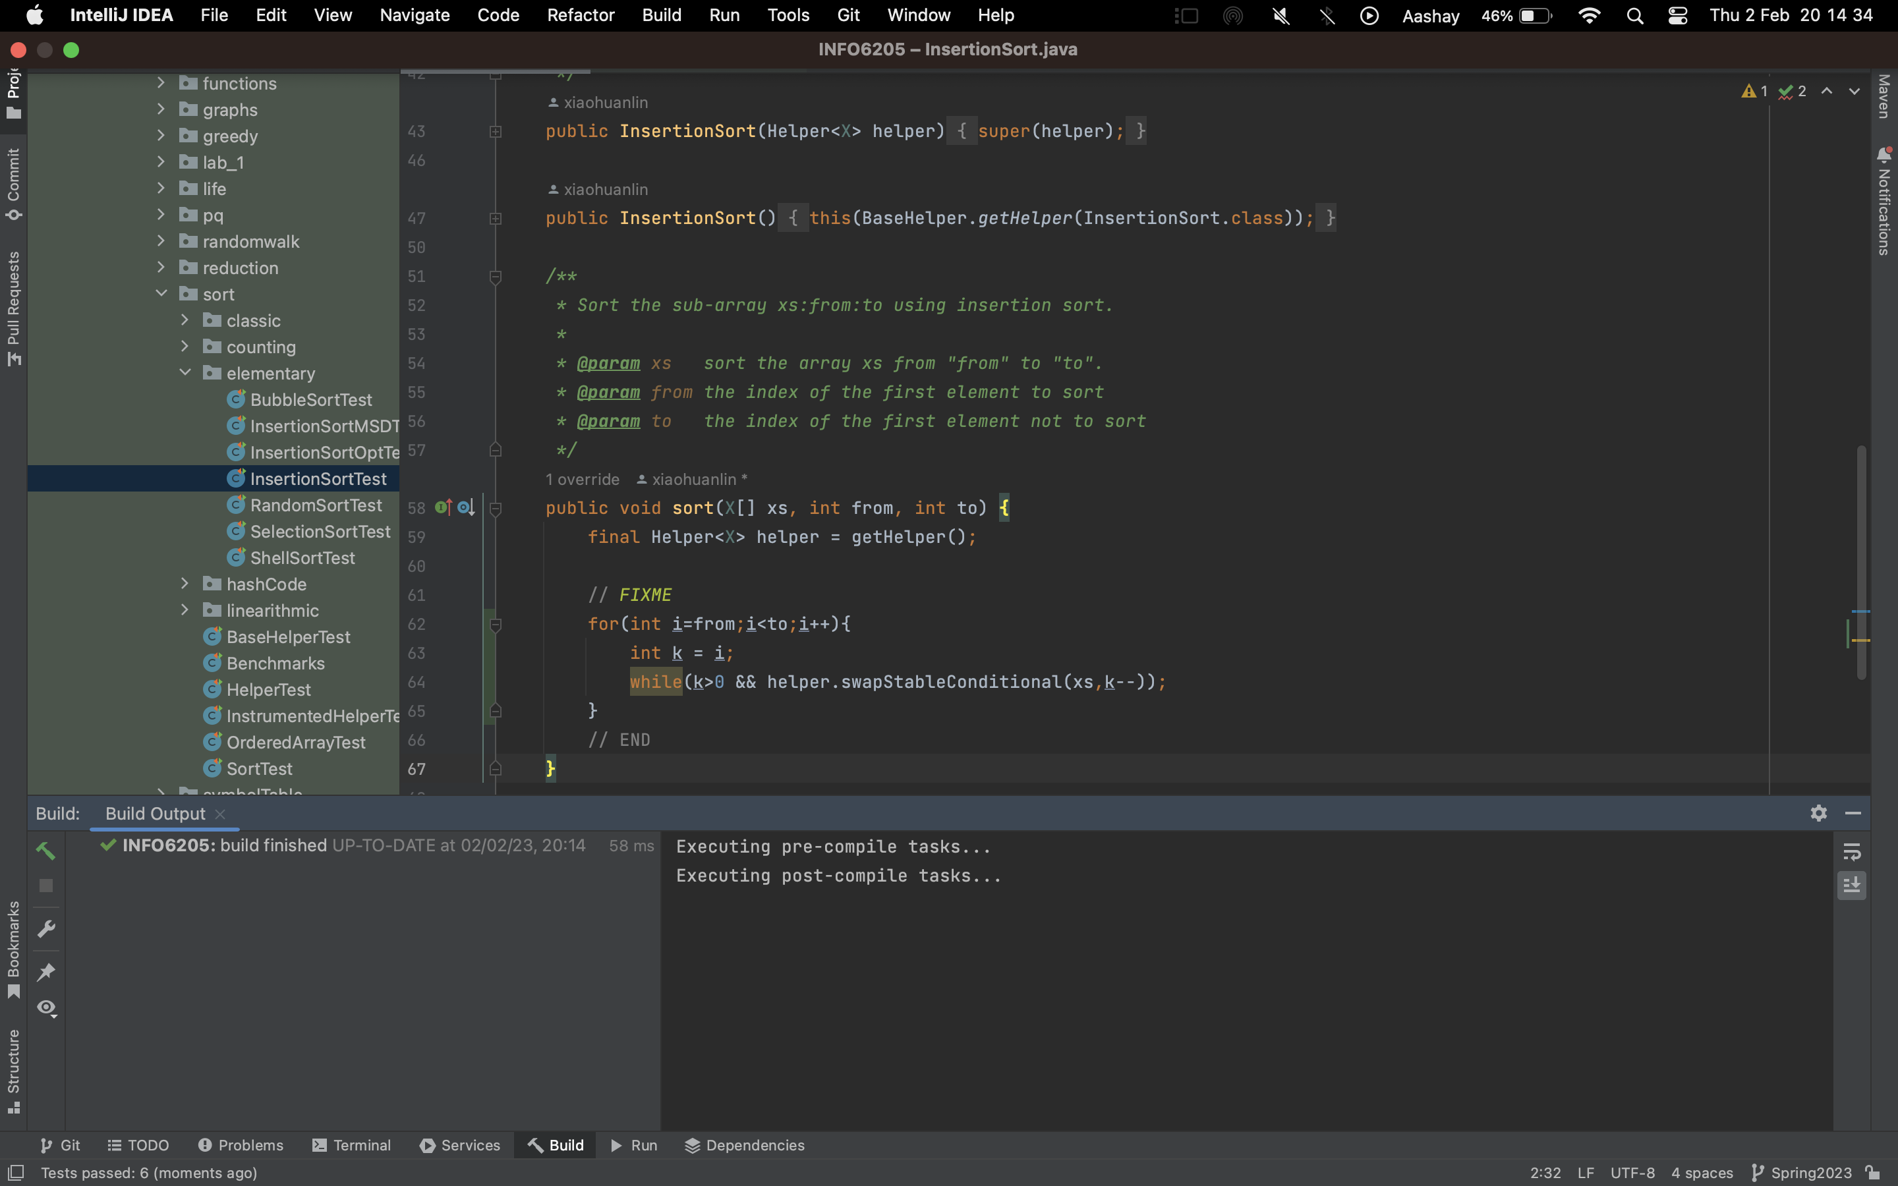

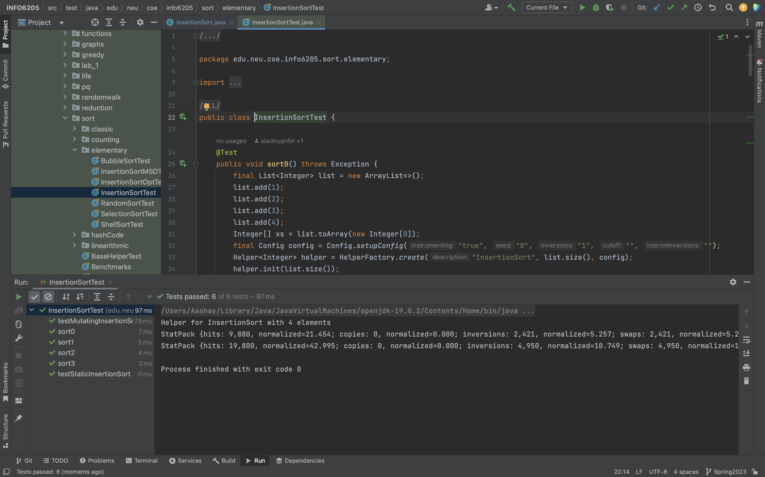

***Part 3 - Implement a main program (or you could do it via your own unit tests) to actually run the following benchmarks: measure the running times of this sort, using four different initial array ordering situations: random, ordered, partially-ordered and reverse-ordered.***

Out

Output:



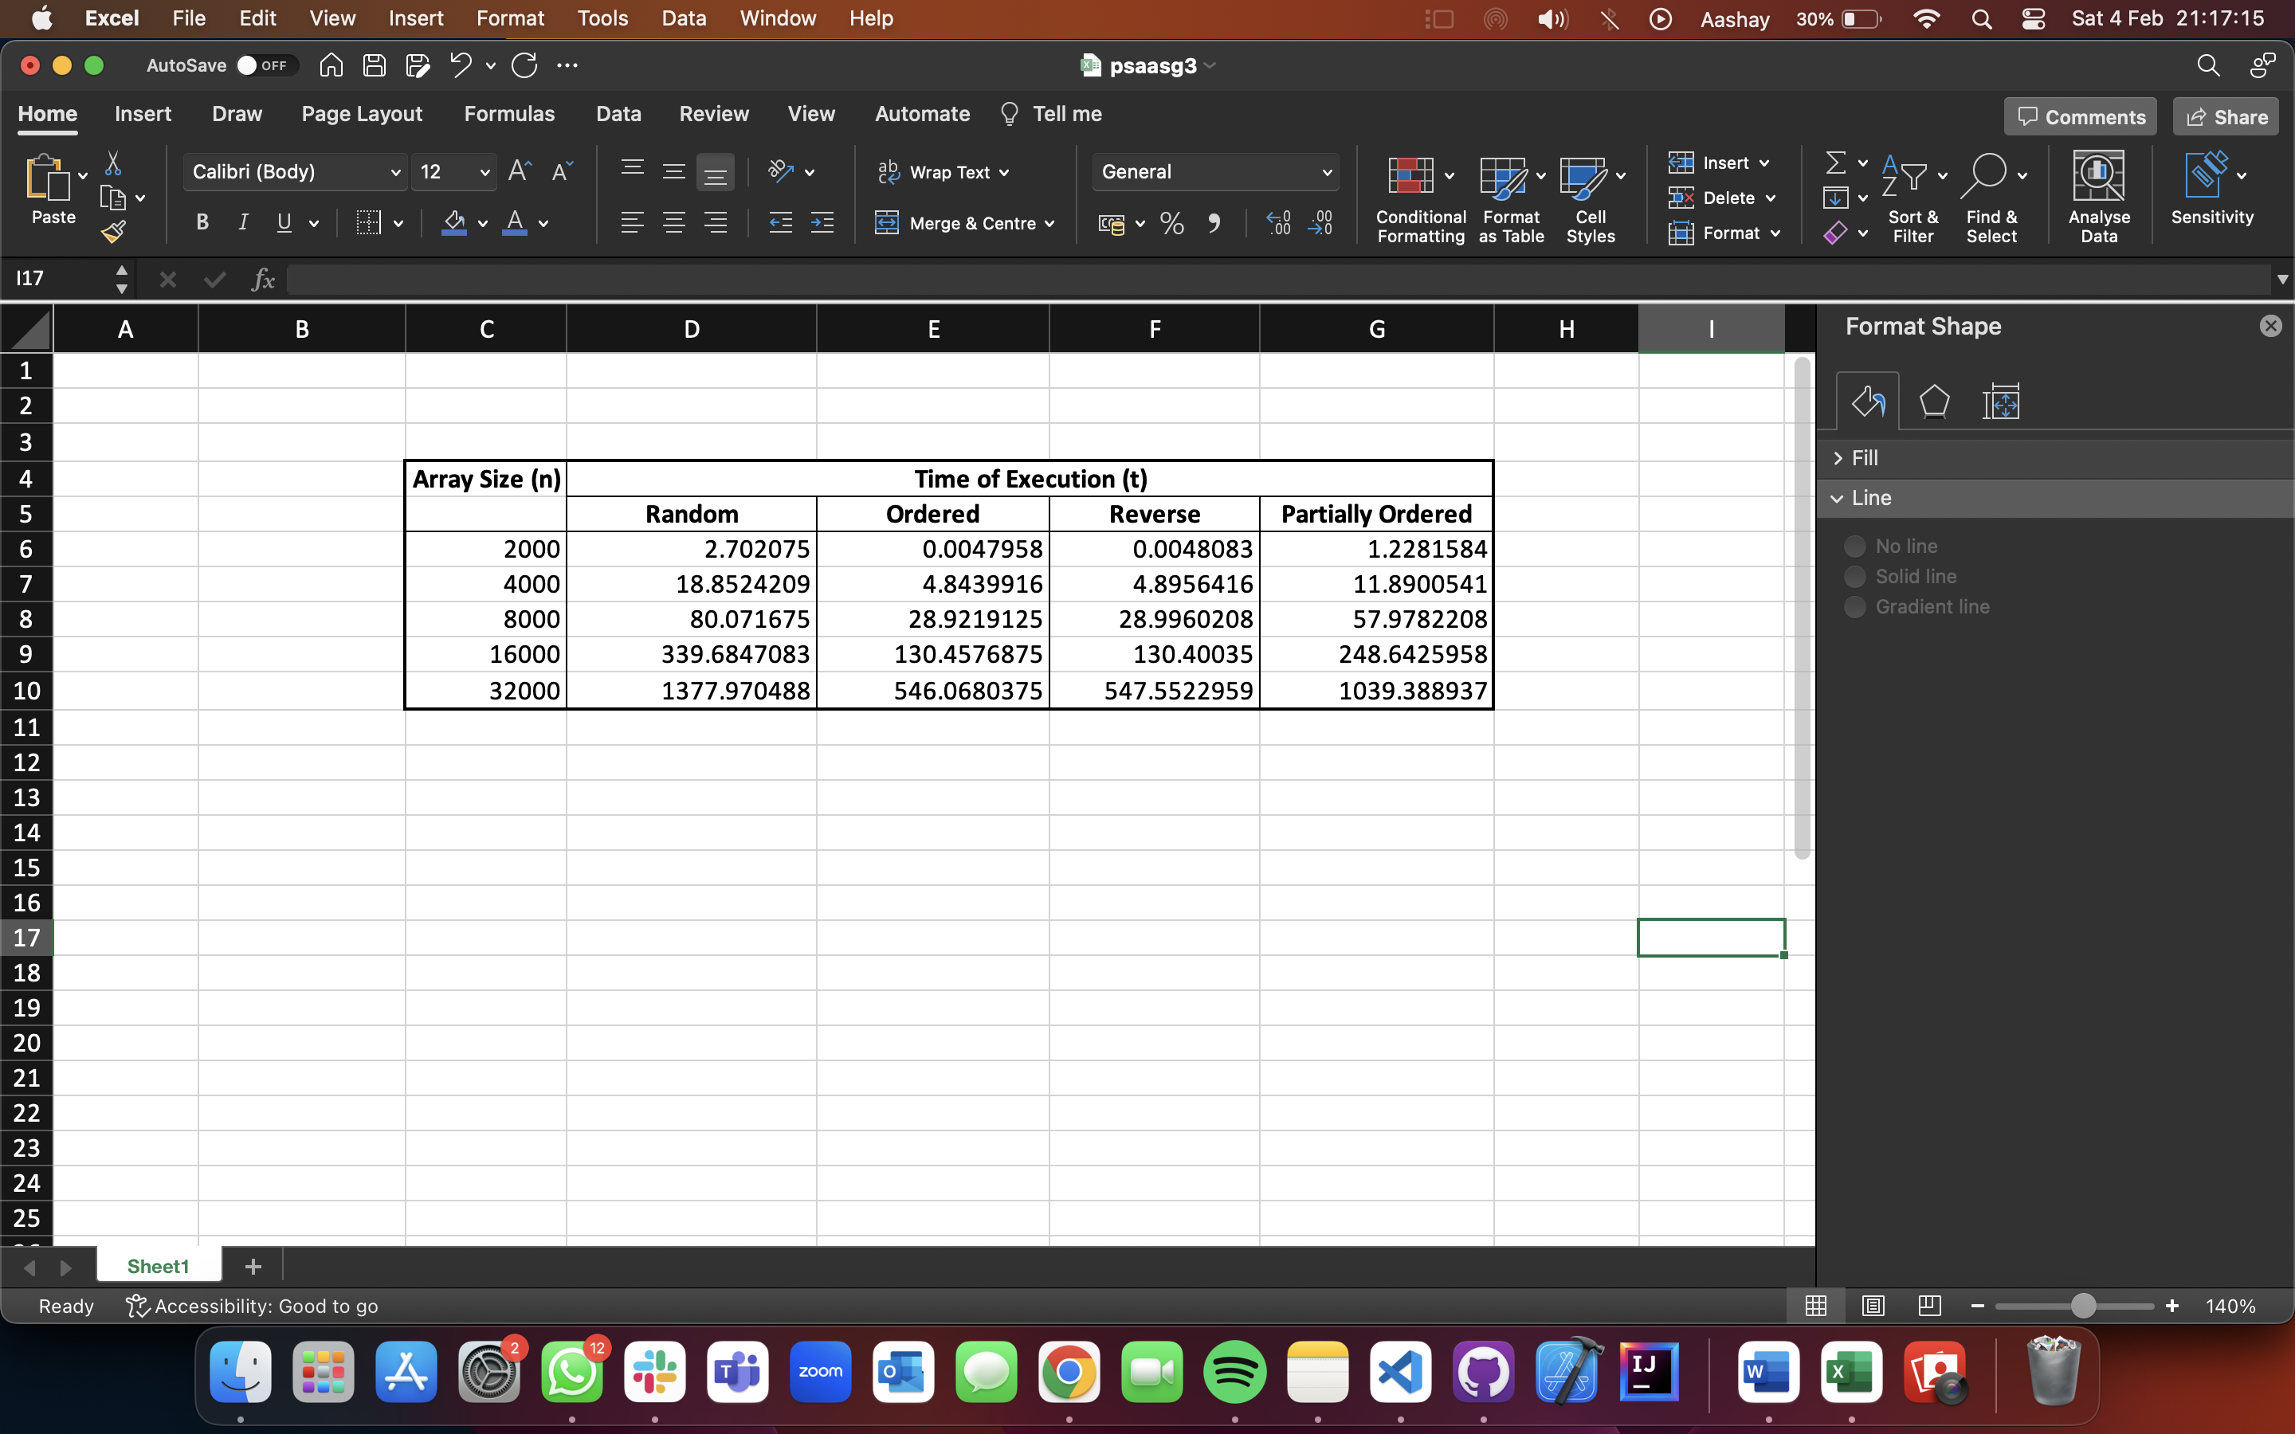

Conclusion:

The time taken for sorting

Ordered ~ Reverse < Partially Ordered < Random

And order of growth is quadratic for all.